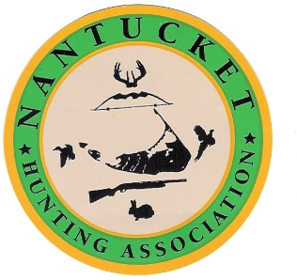
The Nantucket Hunting Association is a non-profit community organization whose mission is to preserve the traditions of ethical hunting and maintain the balance of Nantucket’s wildlife resources. Founded in 1997
Membership Application
Membership is open to all United States citizens who possess a valid Firearms Identification Card and/or valid hunting license and is sponsored by a member in good standing of the Nantucket Hunting Association. Annual dues are $125.00 per year on the first of September and checks are payable to the Nantucket Hunting Association, 20 Amelia Drive, Nantucket MA 02554.

Name: ___________________________________________________________

E-mail:___________________________________________________________

Mailing address: ___________________________________________________

City: _________________ State: ______ Zip: ____________________________

Cell Phone: _______________________ Date of Birth: ____________________

FID#:____________________Hunting Lic. #:______________ State: ____

Hunting Preference (i.e. deer/bow, turkey/shotgun, target/pistol)

List any hunting/Shooting courses and year taken:

Name of Sponsoring Member (Please Print) __________________________________

Sponsoring Members Signature ___________________________________________

Pledge
I certify I am a citizen of good repute of the United States of American; that I am not a member of any organization or group as its purpose or one of its purposes the overthrow by force and violence of the Government of the United States or any of its political subdivisions; that I have never been convicted of violence; that I have not been convicted of or paid a fine for a hunting violation in the past five (5) years; and that, if admitted to membership, I will fulfill the obligations of good sportsmanship and citizenship.

Applicants signature Date

Official Use (approval by 70%-member vote at the meeting)

Meeting date: ________________ Number of voting members_______ Secretary Signature __________________

